XtremityTTTM FLEX: Instructions For Use

Introduction:
The XtremityTTTM FLEX is a flexible inner socket (FIS) that provides uniform wall thickness, easy fabrication with minimal lab space and equipment, and reduced material waste relative to traditional flexible inner sockets. The XtremityTTTM FLEX Preforms are specifically designed to be simple and easy to form with excellent melt strength. The XtremityTTTM FLEX is compatible with the XtremityTTTM Socket System as well as traditional laminated sockets.

Intended use:
The XtremityTTTM FLEX is intended to be used in combination with the XtremityTTTM Socket System or traditional prosthetic socket. XtremityTTTM FLEX should only be provided under the direct supervision of a certified prosthetist. The device is for single patient use.

Product Identification:
Brand: XtremityTTTM FLEX
Category: Leg Prosthesis

Indications for Use:
- Transtibial Amputation
- Distal limb circumference between 24-38cm circumference, measured over a liner at 4cm from the distal end
- Proximal limb circumference that falls within the indicated range on the XtremityTTTM FLEX Size Selection Chart (page 2) according to the length measurement from the mid patella tendon (MPT)

Equipment Needed:
- XtremityTTTM Benchtop Heating Unit
- Silicone Lid Cap for Benchtop Heating Unit
- Heat Gun
- Heatproof Gloves
- Talcum Powder

Sizing the XtremityTTTM FLEX:
Using the correct size of XtremityTTTM FLEX is critical for optimal outcomes. The XtremityTTTM FLEX comes in one profile and three sizes. It will accommodate a wide range of limb shapes and sizes. Extremely conical or unusual shaped limbs may fall outside of our sizing indications.
The XtremityTTTM FLEX is 3.5mm thick and may thin slightly when forming. Follow the proximal limb circumference guide on page 2 to ensure the FIS maintains its uniform wall thickness without being overstretched.

Size Ranges (identified from circumferential measurement 4cm from distal end)
Size 24: 24 – 27.9 cm
Size 28: 28 – 32.9 cm
Size 33: 33 – 38 cm

Size Selection Instructions for XtremityTTTM FLEX:

*Note: the total length from your most proximal trim line to the distal end must measure 29cm or less.

- Distal Circumference: First, take a circumferential measurement 4cm from the distal end of the limb model to determine the FIS size (across the first row of the chart).
- Length: Next, take a length measurement from the Mid-Patella Tendon (MPT) to the distal end of the limb model. Round to the nearest cm.
- Proximal Circumference: Finally, take a circumferential measurement at MPT. Use the length and MPT circumference to ensure that the model does fit within the XtremityTTTM FLEX sizing limits so the is not over stretched.

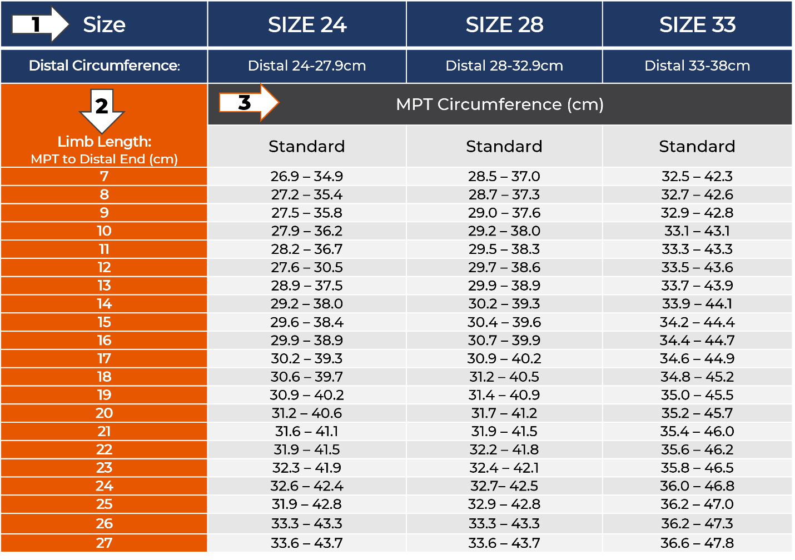

**Critical to the success of the XtremityTTTM FLEX**
Preparing the Limb Model:
The FIS will pick up any defects in the model, so make sure the model is smooth. When preparing the positive model for the XtremityTTTM FLEX, plan your global reductions for a 1 ply fit to accommodate for material shrinkage. This equates to approximately 0.75% less global reduction compared to reductions for a 0 ply fit.

Note: Do NOT use a nylon when pulling the FIS over the positive model. Remove all excessive build-ups proximal to the trim lines.

Preparing the XtremityTTTM FLEX for Heating:
Place the FIS carefully in the Benchtop Heating Unit on the pedestal so that it is not tilted in any direction. Seal the hole in the center of the Benchtop Heating Unit lid with the silicone lid cap to ensure heat does not escape.

Benchtop Heating Unit Settings:
The Benchtop Heating Unit has a setting for FIS (accessible by pressing the FIS button on the heating unit keypad). The FIS Mode was specially designed to heat the XtremityTTTM FLEX. The temperature and time settings for the FIS mode may require a one-time adjustment, see instructions below. Be sure to set the Benchtop Heating Unit to FIS mode each time you form an XtremityTTTM FLEX.

To confirm/adjust temperature and time settings:
- Power the unit on and press the FIS button to select FIS mode. The temperature setting displayed should be 335°. IF the temperature setting is not 335°:
  - Press and hold the “down” arrow until the temperature LED drops in value. When this happens, release the down arrow, and then press the up arrow to reach 335°
  - To save this temperature setting, press and hold the Power Button and the display will turn OFF and then back ON. This indicates that the unit is reset and the new temperature is saved. Do not release your finger until the display turns back on
- Press START to accept the new temperature setting. The display should then read “5:00” to signify the time setting. IF the time setting is not 5:00:
  - Press and hold the “down” arrow until the time LED drops in value. When this happens, release the down arrow, and then press the up arrow to reach 5:00
  - To save this time setting, press and hold the Power Button and the display will turn OFF and then back ON. This indicates that the unit is reset and the new time is saved. Do not release your finger until the display turns back on
- Press START again to accept this setting and begin heating.

By following the procedure above, any changes to the temperature and time settings will be saved and this procedure will not need to be repeated. Simply press the FIS button to return to these settings. If you plan to heat an XtremityTTTM socket, press the SOCKET button and it should read 350°. Proceed with normal heating instructions of the XtremityTTTM socket, ensuring that the temperature setting is at 350° and time setting is 5:00.

Heating of XtremityTTTM FLEX:
- Power the heating unit on
- Press the FIS button (display temperature should read 335°)
- Press Start to accept the FIS temperature setting
- Press Start again to accept the time setting (5:00) and begin heating
- Total heating time is 20-25 minutes

If planning to immediately heat another XtremityTTTM FLEX or XtremityTTTM socket, remove the lid from the heating unit for at least 10 minutes to allow the heating unit to cool before starting again. In the event an error is made in forming, the FIS can be reheated and reformed before it has been trimmed in most cases. Once it has been trimmed, the XtremityTTTM FLEX cannot be fully reheated in the Benchtop Heating Unit and reshaped.

Shaping the XtremityTTTM FLEX:
- Once heated, remove the XtremityTTTM FLEX from the heating unit with gloves and add talcum powder to the inside of the XtremityTTTM FLEX Preform
- Gently stretch the proximal opening as it is fitted over the positive model
- With 4 fingers on both hands inside anterior and posterior brim of the Preform, pull the Preform from the proximal brim with a slight back and forth twisting motion to get an even pull. (Fig. 1)
- As the XtremityTTTM FLEX approaches distal contact, use opposing hands on the midsection if needed to gently pull it fully onto the model until distal contact is made
- Check for distal contact by pressing the distal end gently to assure it is fully seated. Do not push from the distal end of the XtremityTTTM FLEX in an attempt to make distal contact with the positive mold, as wrinkles or deformation of the material may occur
- Pull a latex or similar sealing sleeve over the XtremityTTTM FLEX brim to achieve vacuum seal and apply vacuum. Maintain a vacuum until the FIS reaches room temperature. This should take about 10 minutes**

**Unlike typical sheet formed Flexible Inner Sockets, the XtremityTTTM FLEX is ready for definitive socket fabrication over the XtremityTTTMFLEX once it reaches room temperature.

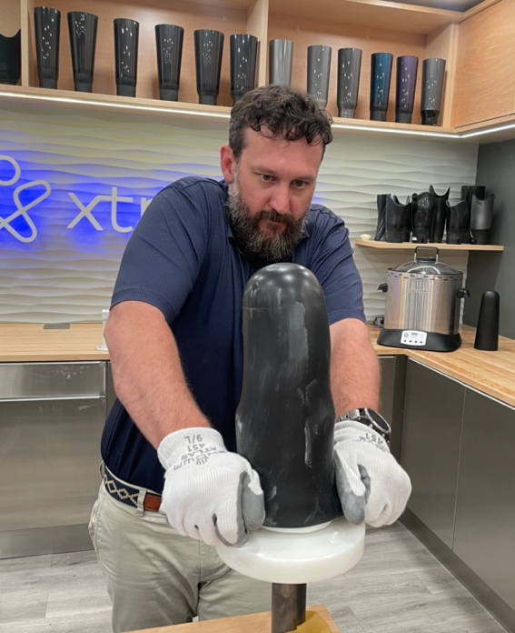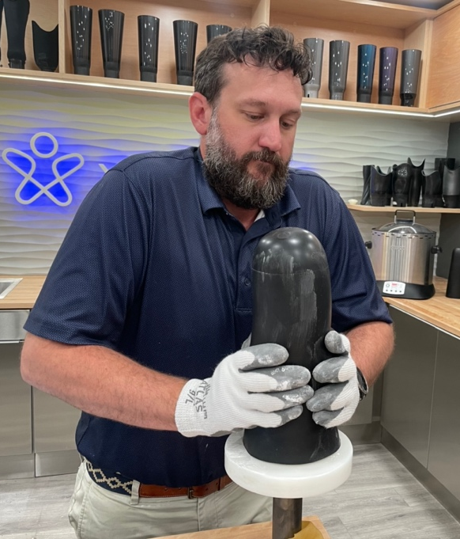
Figure 1: Forming an XtremityTM FLEX

Sizing the XtremityTT Socket:
After the XtremityTTTM FLEX has been formed onto a limb model, take new measurements over the formed XtremityTTTM FLEX on the positive model. Follow the XtremityTTTM socket measuring guidelines to select the correct XtremityTT Socket Preform size from the XtremityTT Socket Sizing Chart.

If the XtremityTTTM Socket Preform size needs to be determined before the XtremityTTTM FLEX is formed, add 2.0 cm to the distal and MPT circumference measurements and add 4 mm to the length measurement from MPT. Use these measurements and the Sizing Chart to select the correct size.

Reminder: the length measurement from the most proximal trim line to the distal end of the positive model cannot exceed 29cm when using XtremityTTTM FLEX.

Forming the XtremityTTTM Socket over the XtremityTTTM FLEX:
- With the XtremityTTTM FLEX formed on the model, pull on a vacuum nylon, twisted and reflected, or with a smooth seam
- If planning to use Velcro to attach the XtremityTTTM FLEX to the XtremityTTTM Socket, adhere both sides of velcro to the XtremityTTTM FLEX to create space for them once the XtremityTTTM Socket is formed. For a smooth transition, place the vacuum nylon over the velcro before pulling the XtremityTTTM Socket. Double sided tape can also be used in place of velcro to help hold the FIS solid inside the socket. When this is used, "dummy" material is not needed to create space
- Determine the correct XtremityTTTM Socket Preform size using proper measurements and Socket Preform Sizing Chart
- Heat and pull the XtremityTTTM Socket Preform according to XtremityTTTM Socket Instructions For Use. Talcum powder or silicone spray can be used
- Vacuum form the XtremityTTTM Socket and leave on the model for 1 hour to cool. This additional time will prevent shrinkage of the XtremityTTTM FLEX

Finishing the XtremityTTTM FLEX and the XtremityTTTM Socket:
It is critical to place a centered hole in the distal end of the finished XtremityTTTM FLEX to achieve optimal suspension with Pin-Lock, Suction or Vacuum. Hole placement is important to not block air or pin passage. Use the following directions to position the hole.

*Do NOT trim or remove the XtremityTTTM FLEX or XtremityTTTM Socket from the limb model.

For ALL suspension systems, mark the distal end of the XtremityTTTM FLEX with a Sharpie through the hole in the base of the socket. (Fig. 2)

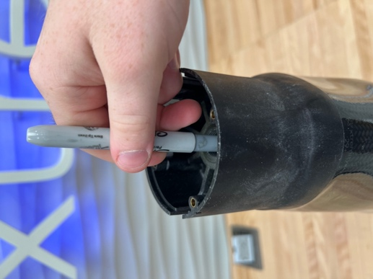
Figure 2: Marking Drilling Location

Follow these instructions for each suspension type.

Pin Lock:
- Use a Sharpie to draw a circle through the hole on the base of the XtremityTTTM Socket
- Use a 3/16” drill bit to drill a guide hole through the center of the marked circle on the XtremityTTTM FLEX until it reaches the limb model
- Trim the XtremityTTTM Socket and XtremityTTTM FLEX. Knock off the XtremityTTTM Socket off the model, leaving the XtremityTTTM FLEX still in place on the positive limb model
- Use a 1-1/4” hole saw to drill out the hole in the bottom of the XtremityTTTM FLEX while still on the plaster model
- Remove the XtremityTTTM FLEX from the limb model
- Smooth, bevel and buff the hole as desired to allow ease of passage of the plunger pin
- Smooth, buff and finish the proximal brim of both the XtremityTTTM FLEX and the XtremityTTTM Socket
- Apply double sided tape or velcro to prevent movement between the XtremityTTTM FLEX and XtremityTTTM Socket if desired

Suction:
- Use a Sharpie to draw a circle through the hole on the base of the XtremityTTTM Socket
- Use a 3/16” drill bit to drill a guide hole through the center of the marked circle on the XtremityTTTM FLEX until it reaches the limb model
- Remove both the XtremityTTTM FLEX and the XtremityTTTM Socket from the limb model
- Smooth, buff and finish the proximal brim of both the XtremityTTTM FLEX and the XtremityTTTM Socket
- Apply double sided tape or velcro to prevent movement between the XtremityTTTM FLEX and XtremityTTTM Socket if desired

Vacuum:
- Use a Sharpie to draw a circle through the hole on the base of the XtremityTTTM Socket
- Use a 3/16” drill bit to drill a guide hole through the center of the marked circle on the XtremityTTTM FLEX until it reaches the limb model
- Use a 1/16” drill bit to drill a hole from the distal end, through the center of the Base Vacuum Port, through the XtremityTTTM FLEX into the limb model
- Remove both the XtremityTTTM FLEX and the XtremityTTTM Socket from the limb model
- Smooth, buff and finish the proximal brim of both the XtremityTTTM FLEX and the XtremityTTTM Socket
- Apply double sided tape or velcro to prevent movement between the XtremityTTTM FLEX and XtremityTTTM Socket if desired

Adjusting the XtremityTTTM FLEX and XtremityTTTM Socket:
Traditional flexible inner sockets are often used to adjust fit by grinding on the flexible material, adding padding in between it and the socket, or cutting windows into the definitive socket. This practice is no longer needed with the XtremityTTTM Socket system.

To Adjust:
- Remove the XtremityTTTM FLEX from the XtremityTTTM Socket
- Using a heat gun, gently heat the outside and inside of the XtremityTTTM Socket, keeping the heat gun at least 2 inches from the socket, slowly moving it for even heating. Once pliable, adjust the XtremityTTTM Socket as necessary
- The XtremityTTTM FLEX will flex to conform to this adjustment; however, the XtremityTTTM FLEX can also be heated and adjusted in the same manner as the Socket Once both the XtremityTTTM Socket and XtremityTTTM FLEX are warm enough to form, quickly insert the FIS and hand form the materials to the desired shape

Care and cleaning:
XtremityTTTM FLEX can be cleaned with soap and water, isopropyl alcohol, or any water-based spray cleaner. Solvents such as acetone and Goo-Off can be used to remove tape gum and may change the surface texture but will not harm the material.

Identification of symbols used on product labeling:
Symbol | Meaning or Definition
 | Catalogue Number – Reference Number
 | Serial number
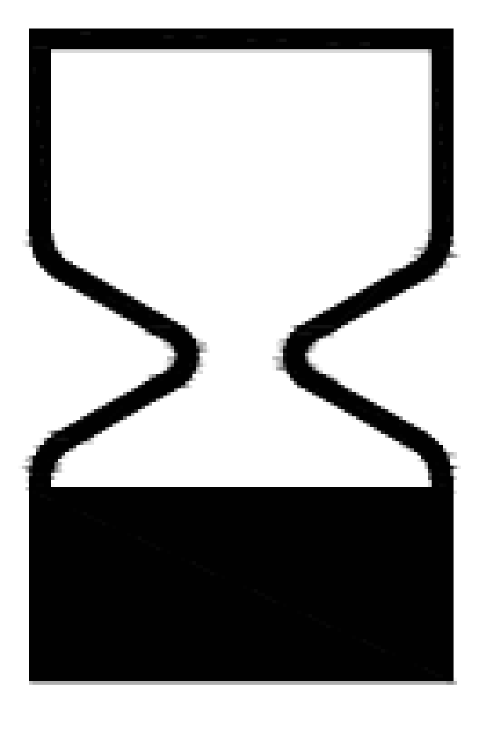 | Expiration date of product
 | Manufacturer:  WillowWood Global  15441 Scioto-Darby Rd  PO Box 130  Mt Sterling, OH 43143, USA
 | Consult the instructions for use for important warnings and precautions that are not on the device itself
 | Consult instructions for use
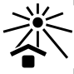 | Keep away from sun/heat
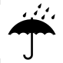 | Keep dry
 | Do not use if package Is damaged
 | Prescription use only
 | Authorized representative in the European Community
 | Product is provided nonsterile
 | Do not reuse between patients
 | CE Mark, Conformity European.  Designates that the product labeled is authorized for sale in European countries. Regulation (EU) 2017/745
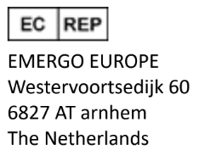
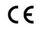
Willowwood Global LLC
15441 Scioto-Darby Rd

PO Box 130
Mt Sterling, OH 43143, USA

