Xtremity Benchtop Heating Unit (240V)

Instructions for Use

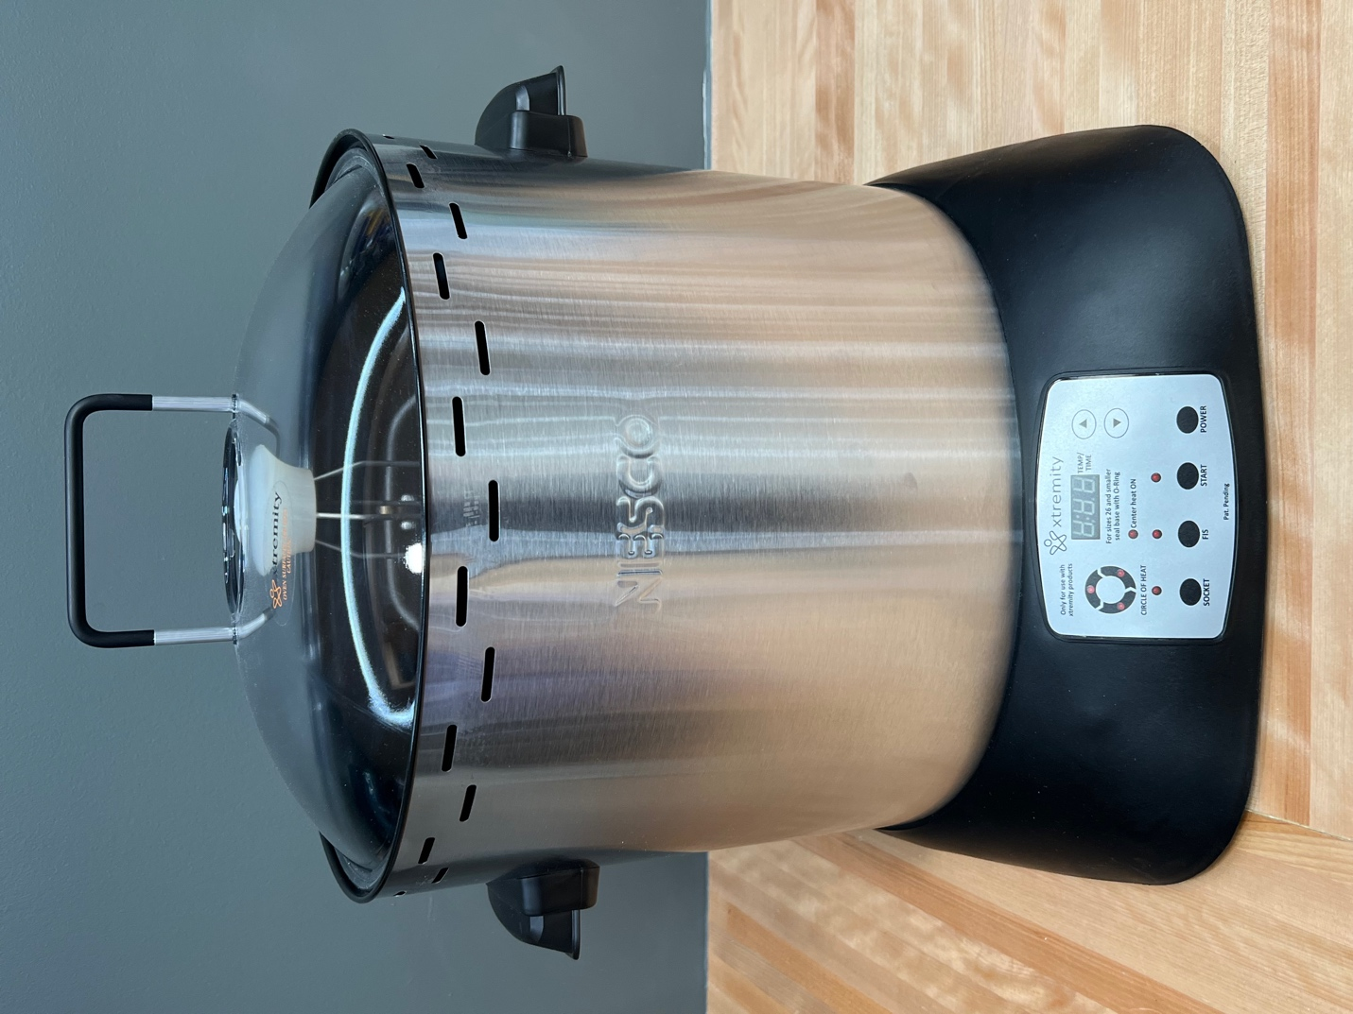
Xtremity Part No: XTBK-A1101-001EU-00000

TABLE OF CONTENTS
IMPORTANT SAFEGUARDS ………………………………………………………………………………………….1
POWER CORD AND PLUG NOTIFICATIONS……………………………………………………………………3
INTRODUCTION……………………………………………………………………………………………………………4
COMPONENTS……………………………………………………………………………………………………………..5
CONTROL PANEL FEATURES…………………………………………………………………………………………6
BEFORE FISRT USE……………………………………………………………………………………………………….6
OPERATION………………………………………………………………………………………………………………….6
CARE AND CLEANING INSTRUCTIONS……………………………………………………………………………9
STORAGE AND DISPOSAL……………………………………………………………………………………………..9
IMPORTANT GUIDELINES………………………………………………………………………………………………10
TROUBLESHOOTING………………………………………………………………………………………………………10
REPAIRS…………………………………………………………………………………………………………………………10
LIMITED ONE YEAR WARRANTY……………………………………………………………………………………..11
DISPOSAL……………………………………………………………………………………………………………………….11
MANUFACTURER……………………………………………………………………………………………………………12

IMPORTANT SAFEGUARDS
READ ALL INSTRUCTIONS.
1. This Benchtop Heating Unit is intended to be used for heating Xtremity products only.
2. Do not touch hot surfaces. Use heat resistant gloves. Observe the label on the unit lid.


3. To protect against electrical shock and personal injury, do not immerse this Benchtop Heating Unit, including cord and plug, in water or other liquid.
4. The Benchtop Heating Unit is not intended to hold or contain any liquids.
5. This Benchtop Heating Unit is not a toy. Close supervision is necessary when the Benchtop Heating Unit is used near children. Store this Benchtop Heating Unit in a safe place, out of the reach of children.
6. Unplug from outlet when not in use. Allow to cool for at least 5 minutes before operating.
7. Do not operate the Benchtop Heating Unit with a damaged cord or plug or after the Benchtop Heating Unit malfunctions or has been damaged in any manner. To avoid hazards, please return the Benchtop Heating Unit to your local distributer or manufacturer.
8. Do not attempt to repair the Benchtop Heating Unit.
9. Do not use any accessory attachments or parts not recommended by the Xtremity as they may cause injuries, void the warranty, and damage the Xtremity sockets.
10. Always place the Benchtop Heating Unit on a firm and stable surface. Make sure the surface is clean and dry.
11. Do not use this Benchtop Heating Unit on wet or hot surfaces or near any heat sources.
12. Do not place on or near a hot gas or electric burner, or in an oven.
13. Do not use outdoors. This unit is intended for indoor use only.
14. The Benchtop Heating Unit is intended to be used under the following environmental conditions:
- Altitude: up to 2000m (6561ft)
- Ambient Temperature: 5 °C to 40 °C (41 °F to 104 °F)
- Maximum relative humidity 80 % for temperatures up to 31 °C (88 °F) decreasing linearly to 50 % relative humidity at 40 °C (104 °F);
- MAINS supply voltage fluctuations up to ±10 % of the nominal voltage.
- Use only in office and laboratory areas. Do not use in industrial environments and construction sites.
15. Use the Xtremity Benchtop Heating Unit in well ventilated areas. An air exchange of a minimum 10 volumes per hour is recommended.
16. To disconnect the Benchtop Heating Unit, push the power button to turn the unit OFF, then remove plug from wall outlet.
17. Do not use Benchtop Heating Unit for other than intended use.
18. Do not operate unattended.
19. Do not clean with metal scouring pads. Pieces can break off the pad and touch electrical parts, creating a risk of electric shock.
20. This Benchtop Heating Unit is not intended for use by children or persons with reduced physical, sensory, or mental capabilities, or lack of experience and knowledge, unless they have been given supervision or instruction concerning use of the Benchtop Heating Unit by a person responsible for their safety.
21. Do not let cord hang over edge of table or counter, touch hot surfaces and never pull on the cord.
22. Before plugging the Benchtop Heating Unit in or operating it, make sure your hands are dry. Do not operate the Benchtop Heating Unit if the cord or plug is wet.
23. A fire may occur if the Benchtop Heating Unit is covered or touching flammable material, including curtains, draperies, walls, and the like, when in operation. Keep unit away from all flammable materials.
24. When disconnecting, to avoid any injury, unplug by grasping the plug, not cord.
25. The inner heating elements become VERY HOT during use. Never touch the inner heating elements when the Benchtop Heating Unit is in operation.
26. When moving the Xtremity Benchtop Heating Unit, make sure the cord is unplugged, the unit is cooled off and there is no socket inside the unit. Always use the built in handles when moving the unit.
27. To access a virtual copy of this document visit the following address: https://xtremity.com/products/

POWER CORD AND PLUG NOTIFICATIONS
Short Cord Instructions
A short power supply cord is provided to reduce the risk resulting from becoming entangled in or tripping over a longer cord. Extension cords may be used if care is exercised in their use. If an extension cord is used, the marked electrical rating of the cord should be at least as great as the electrical rating of the Benchtop Heating Unit. The longer cord should be arranged so that it will not drape over the tabletop where it can be pulled on by children or tripped over. Do not attempt to repair the cord or replace it with an inadequately rated cord.

INTRODUCTION
The Xtremity Benchtop Heating Unit was specifically designed and configured to heat up Xtremity products safely and efficiently before forming. It is very easy to operate, and it offers consistent results.
Technical Specifications:
Operation Mode: Socket
Maximum Power: 795W
Nominal Voltage: 240VAC
Frequency: 50/60 Hz
Maximum heating time: 40 minutes
Maximum heating temperature 350ºF

Operation Mode: FIS (Flexible Inner Socket)
Maximum Power: 625W
Nominal Voltage: 240VAC
Frequency: 50/60 Hz
Maximum heating time: 40 minutes
Maximum heating temperature 335ºF

The front control panel has a digital display that shows Benchtop Heating Unit inside temperature and countdown to the end of the heating cycle. While in the password protected configuration mode, it has adjustments for heating temperature and time at temperature.
The inside rack assembly allows for easy placement of Xtremity products. It has mechanical compensation for thermal expansion of the sockets to prevent wrinkling. The specially designed lid keeps the socket base cold to prevent any unwanted deformations and it is transparent for convenient viewing of the socket during the heating cycle.
This instruction manual will help ensure maximum performance and product life. Please read the entire manual before using the product for the first time. Keep this manual as a reference and save for future use.

COMPONENTS
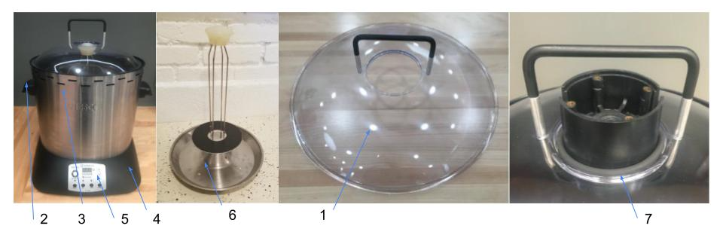
- Viewing Cover with Handle
- Side Handles
- Main Body
- Plastic Base
- Control Panel
- Rack Assembly
- O-Ring

Handle Assembly
- Place screws through holes on either side of the large center hole.
- Place spacers on both screws.
- Attach screws to the black handle.
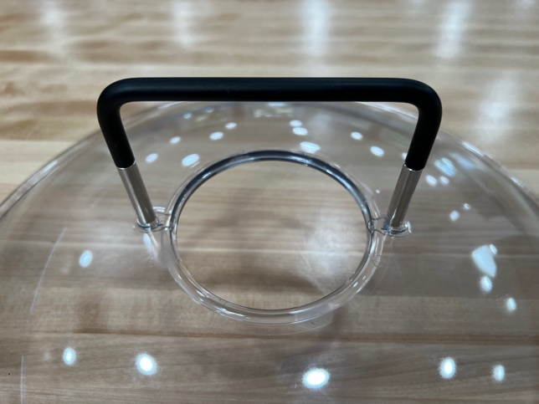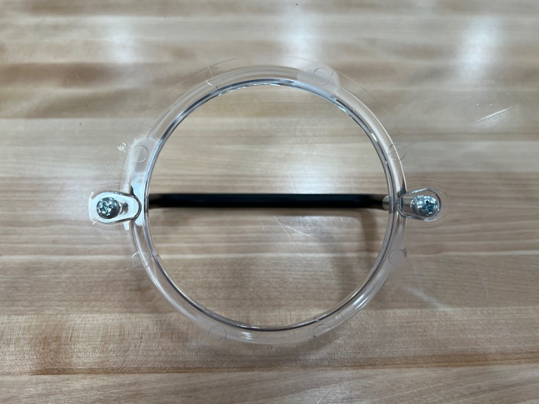

CONTROL PANEL FEATURES
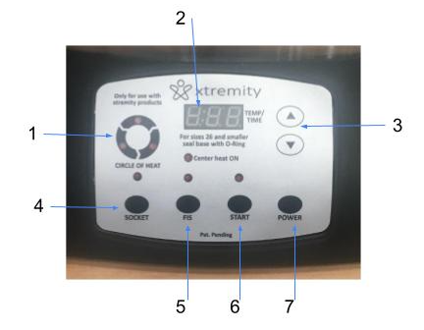
- Outer Heater Elements Cycle Indicator
- Digital Display
- Temperature and Time Adjustment. Temperature adjustment range 250ºF to 350 ºF. Time at temperature adjustment range 1 min to 5 min.
- Socket Button. Selects the heating cycle for a standard socket.
- FIS Button. Selects the heating cycle for a Flexible Inner Socket.
- Start/Pause Button. Starts and Pauses the heating cycle.
- Power Button. Turns the Benchtop Heating Unit ON and OFF.

BEFORE FIRST USE
1. Unpack the Benchtop Heating Unit and remove all packaging and accessories.
2. It is normal for some smoke and odor to occur from the Benchtop Heating Unit when using it for the first time. This is not harmful.

OPERATION
- Place the Benchtop Heating Unit on a flat, heat resistant surface.
- Plug the unit into a grounded outlet. Make sure that the access to the outlet is not blocked by the Benchtop Heating Unit
- Remove the lid and place the socket inside the Benchtop Heating Unit as shown (FIG.1)

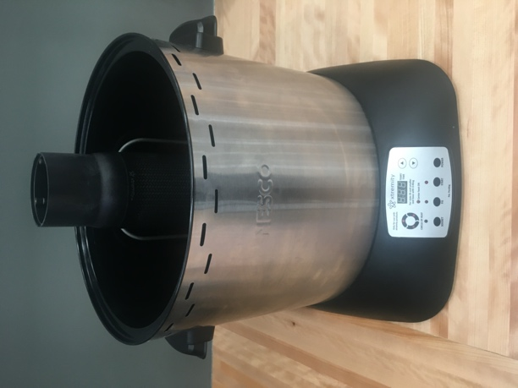
FIG.1

- POWER ON the Benchtop Heating Unit
- Select Socket or FIS (Flexible inner Socket)
- Verify the set temperature (FIG.2)

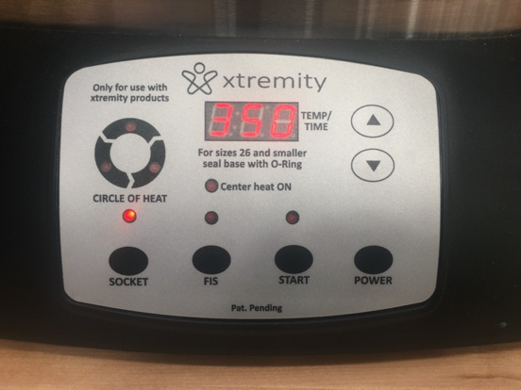
FIG.2
- Press START
- Verify time at temperature (FIG.3)

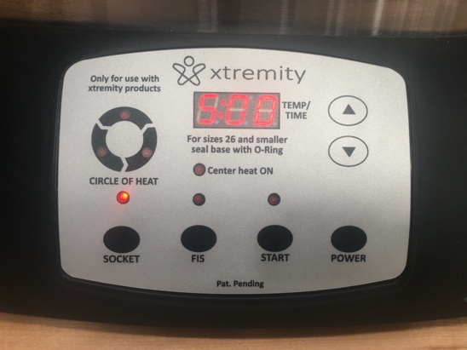
FIG.3

- Press START

- The LCD display will show current temperature inside the Benchtop Heating Unit (FIG .4)

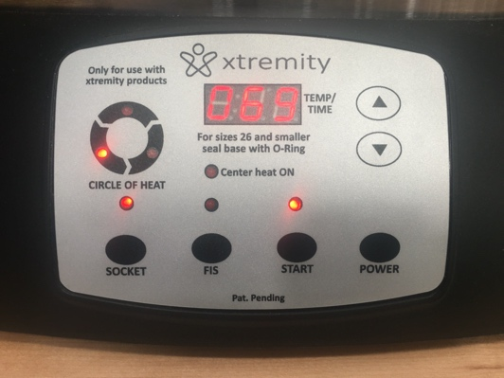
FIG.4

- Once the Benchtop Heating Unit reaches the set temperature, a 1 to 5-minute countdown will start (FIG. 5)
FIG.5

- When the countdown finishes, the LCD display will show “End” (FIG. 6). A buzzer will prompt the operator the heating cycle is finished
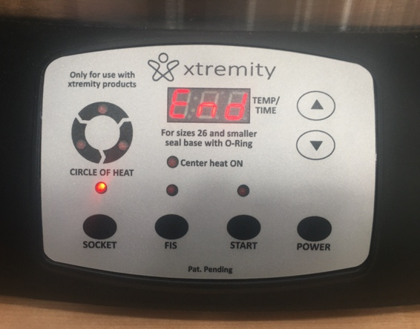
FIG.6

- Using heat resistant gloves, promptly remove the lid and remove the socket from the Benchtop Heating Unit.
The Benchtop Heating Unit allows for temperature and time at temperature settings.

Setting Temperature and Time
- POWER ON the Benchtop Heating Unit
- Select Socket or FIS (Flexible inner Socket)
- Hold down the DOWN button for 5 seconds
- Adjust temperature to the desired set point
- Press START
- Adjust time at temperature
- Hold down the POWER button for 5 second. This will save the set values for temperature and time.
- Benchtop Heating Unit will always POWER ON with the previously saved values for temperature and time.
- The unit allows for saving separate values for temperature and time for the two modes SOCKET and FIS (Flexible Inner Socket).

CARE AND CLEANING INSTRUCTIONS
- Turn off the Benchtop Heating Unit by pressing “POWER” on the Control Panel.
- Remove the plug from the wall outlet and allow the Benchtop Heating Unit to cool completely.
- Clean all Benchtop Heating Unit components with a damp cloth. Dry thoroughly with a paper towel or soft cloth. Do not use abrasive cleaners on interior or exterior surfaces. NEVER spray water or cleaners directly onto the interior surface of the Main Body.
- Clean the exterior surface of the Main Body with a damp cloth after each use. Dry thoroughly with a soft cloth. DO NOT SPRAY OR IMMERSE THE MAIN BODY OF THE BENCHTOP HEATING UNIT IN WATER OR ANY OTHER LIQUID.

STORAGE AND DISPOSAL
STORAGE
- NEVER store the Benchtop Heating Unit on its side. Store the Benchtop Heating Unit on a flat, clean, cool, dry area out of the reach of children and pets.
- Always ensure that the Benchtop Heating Unit is unplugged and has cooled down completely before storing or cleaning.
- Clean with a damp cloth and dry thoroughly before storing.
- Save the packaging for transporting or storage of the Benchtop Heating Unit when not in use for extended periods of time.
DISPOSAL
This product contains electronic equipment and should not be disposed with general waste. Please contact your local distributor or the WillowWood Global Customer Service Team at 1-970-429-4203 for instructions to have your product collected.

IMPORTANT GUIDELINES
- Heating cycles will vary according to socket geometry. Xtremity is configured to bring a socket to a forming temperature and hold it there for a specific amount of time.
- The forming temperatures and times at temperature settings are specific to every product and communicated to the end user
- The Xtremity Benchtop Heating Unit has a preset maximum temperature limit of 400 ºF. The unit will stop automatically when this limit is reached.
- The unit can handle TRANSIENT OVERVOLTAGES up to the levels of OVERVOLTAGE CATEGORY lI and TEMPORARY OVERVOLTAGES occurring on the MAINS supply.

TROUBLESHOOTING
The unit is programmed to detect a defective temperature sensor. In an event of a broken (disconnected), the Xtremity Benchtop Heating Unit will display Err on the front panel and will turn OFF the heating elements. A shorted temperature sensor will cause the unit to turn itself OFF.
- Unit not powering ON when the Power button is pushed.
  - Check to make sure the power cord is plugged in, and the power outlet is functioning.
  - Temperature sensor could be shorted
- Socket base too hot (26 sockets only)
  - Make sure the provided O-ring is used as instructed.
- Confirm all 8 of the heating element connections (female/male spade) are all secured tightly, located underneath the bottom lid.
  - Refer to BHU Connection Troubleshooting Guide

REPAIRS
All repairs will be performed by qualified WillowWood Global personnel or designated Service Provider.
- Always unplug the unit before performing any service
- Upon completing the service check the following:
  - Bottom cover installed with all screws secured
  - Rubber feet installed
  - Power cord free from broken wires, broken insulation, or other signs of damage
  - Bottom plastic enclosure free from cracks and deformation

LIMITED ONE YEAR WARRANTY
WillowWood Global warrants the original purchaser that your product will be free from defects in material and workmanship for a period of one year from date of purchase. Product must be used only for Xtremity products in accordance with the instructions. Should your product prove defective within one year from date of purchase, contact our Customer Service Team at 1-970-429-4203 with an explanation of the claim. If a viable warranty claim is determined, a customer service member will provide you with the necessary details to have your unit repaired or replaced. Under this limited warranty, we undertake to repair or replace any parts found to be defective at our sole discretion. This limited warranty is void if the unit is connected to an unsuitable electrical supply or dismantled or interfered with in any way or damaged through misuse. This warranty is not transferable.
LIMITATION OF REMEDIES AND DAMAGES: Except for the limited warranty and remedies expressly stated above, WillowWood Global shall not be liable to you, or to anyone claiming by or through you, for any obligations or liabilities, including, but not limited to, obligations or liabilities arising out of breach of contract, breach of warranty, statutory claims, negligence or other tort or any theory of strict liability, with respect to the product or the WillowWood Global acts or omissions or otherwise. Buyer agrees that in no event shall the WillowWood Global be liable for incidental, compensatory, punitive, consequential, indirect, special or other damages. Warranty does not cover consequential or incidental damages such as property damage and does not cover incidental costs and expenses resulting from any breach of this warranty, even if foreseeable. Some states or provinces do not allow the exclusion or limitations of incidental or consequential damages, so the above limitation or exclusion may not apply to you depending on the State or Province of purchase.

Identification of symbols used on product labeling:
Symbol | Meaning or Definition
 | Catalogue Number – Reference Number
 | Lot Number
 | Date of manufacture
 | Manufacturer:  WillowWood Global  15441 Scioto-Darby Rd  PO Box 130  Mt Sterling, OH 43143, USA
 | Consult the instructions for use for important warnings and precautions that are not on the device itself
 | Consult instructions for use
 | Keep away from sun/heat
 | Keep dry
 | Do not use if package Is damaged
 | Prescription use only
 | Authorized representative in the European Community
 | Product is provided nonsterile
 | Do not reuse between patients
 | Self-certified in accordance with the European Medical Device Directive 2017/794
 | Medical device


WillowWood Global
15441 Scioto Darby Road
PO Box 130

Mt. Sterling, OH 43143, USA

